**List Command**

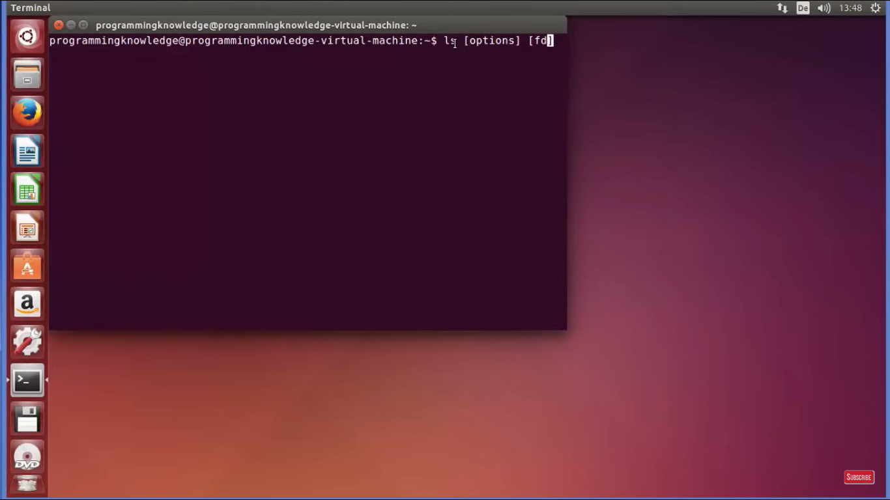

[options] – These options we can use with ls command

[fd] – File or Directory name

LS – shows us the contents of home directory

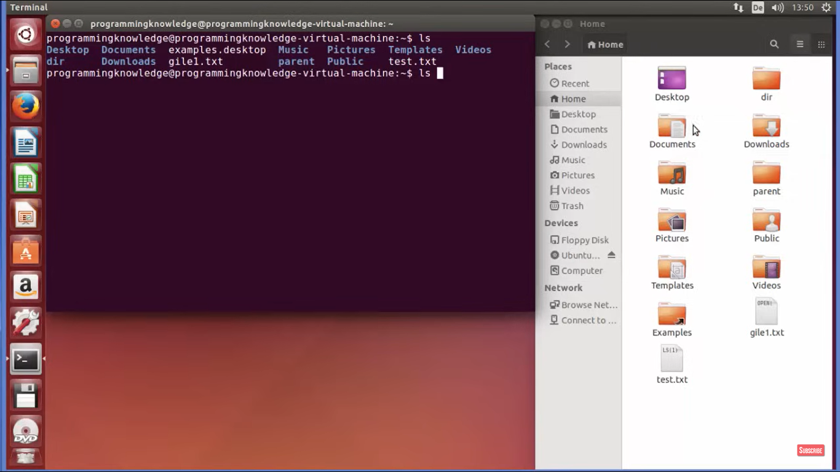

**>>ls Documents/ - To list out the contents in Documents folder**

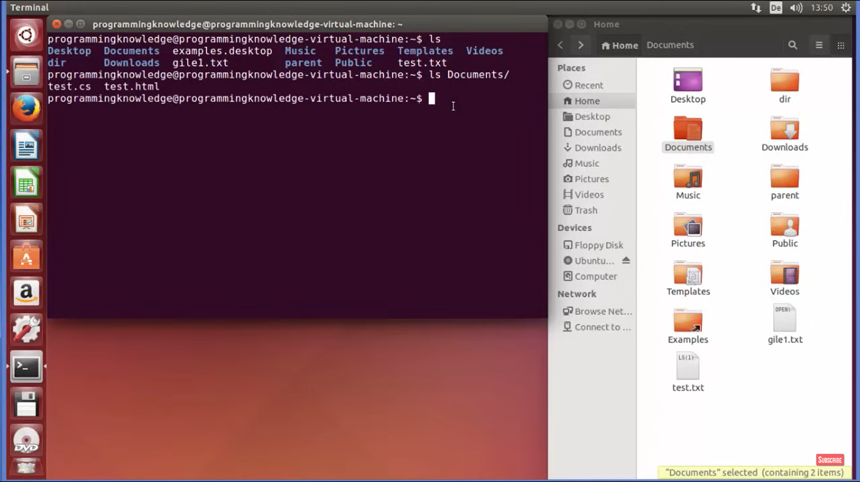

**>>ls Downloads/**

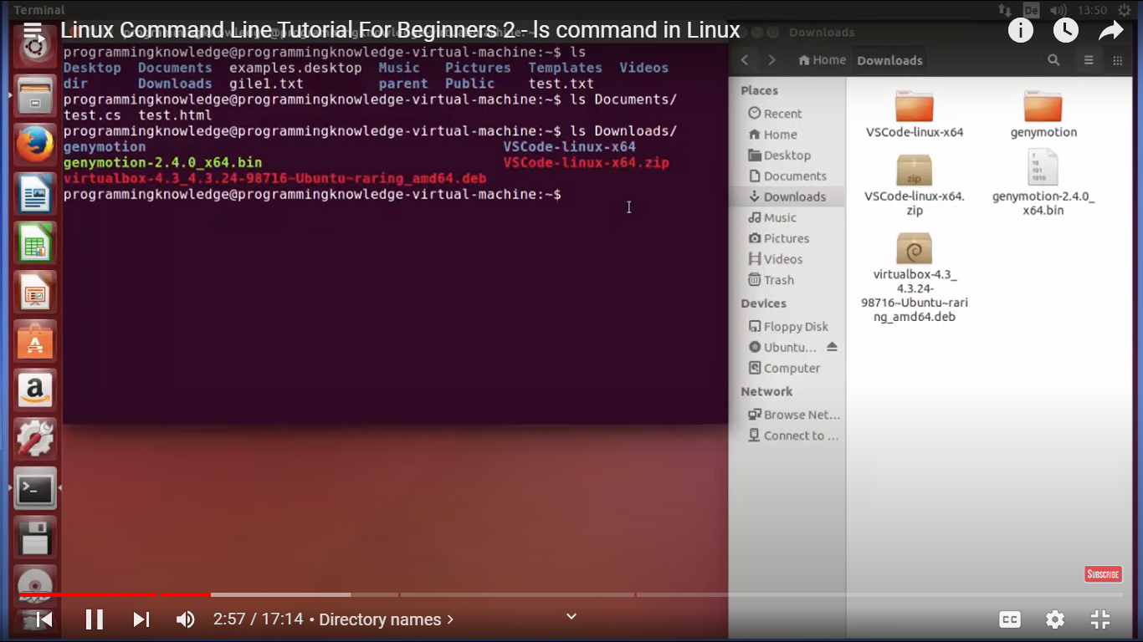

>>ls / -To list the content of root directory

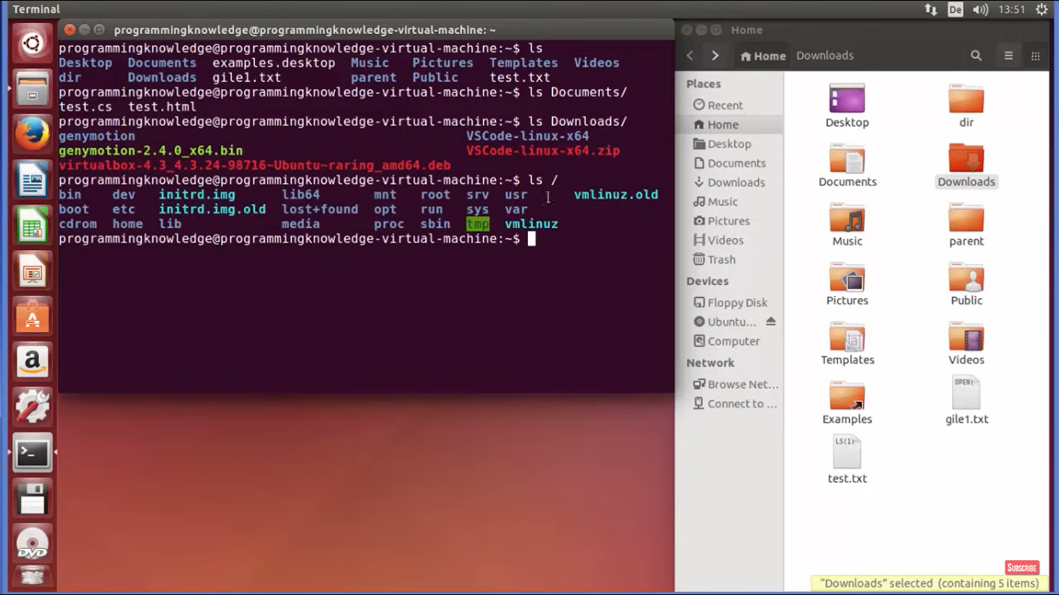

**Pwd – present working directory**

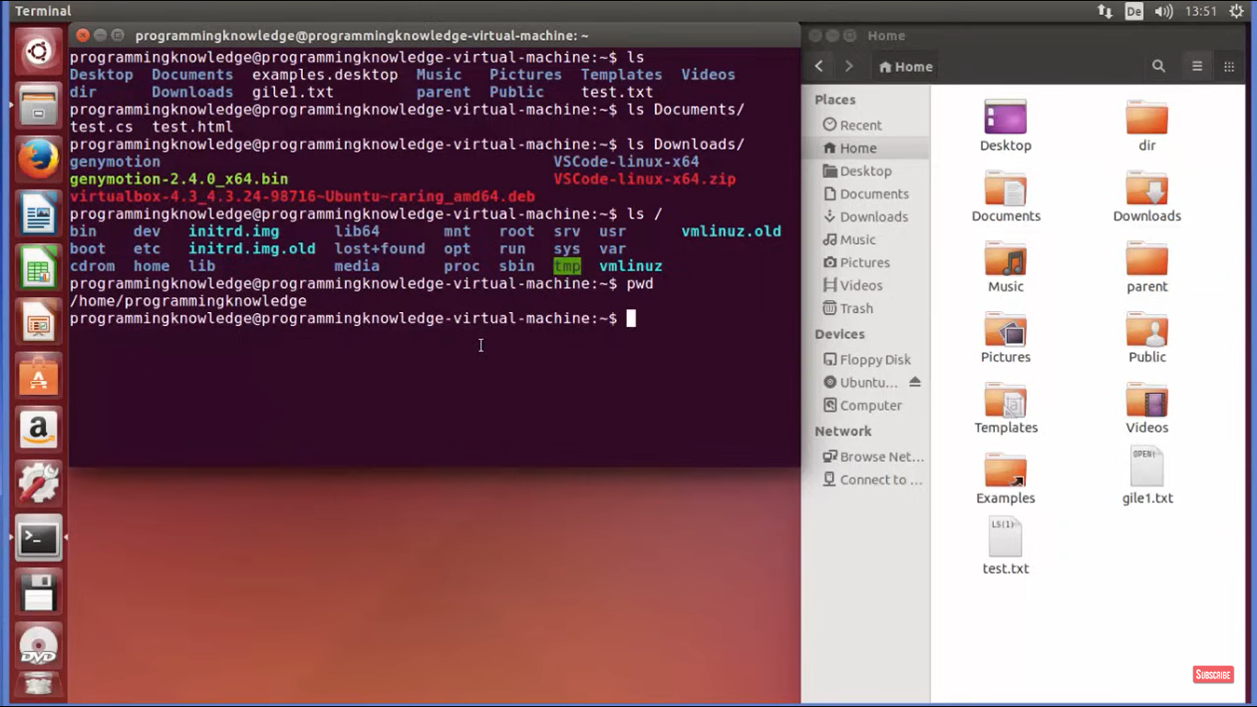

**>>ls ~ - To give the contents same as ls**

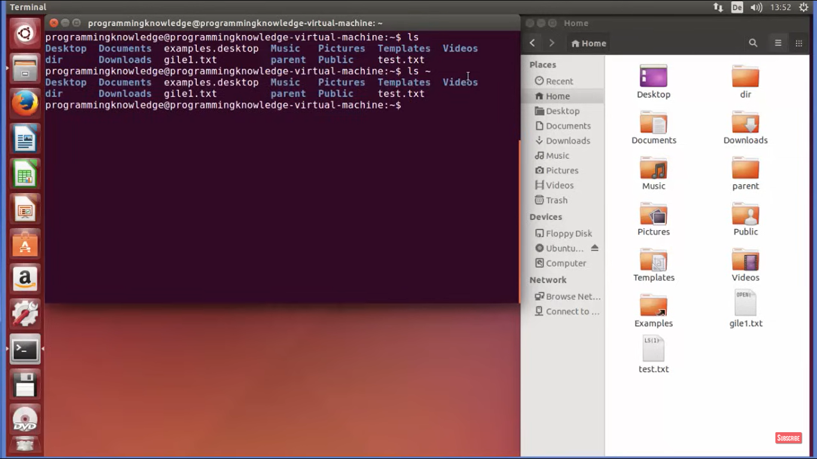

**>>ls .. -> One step back directory**

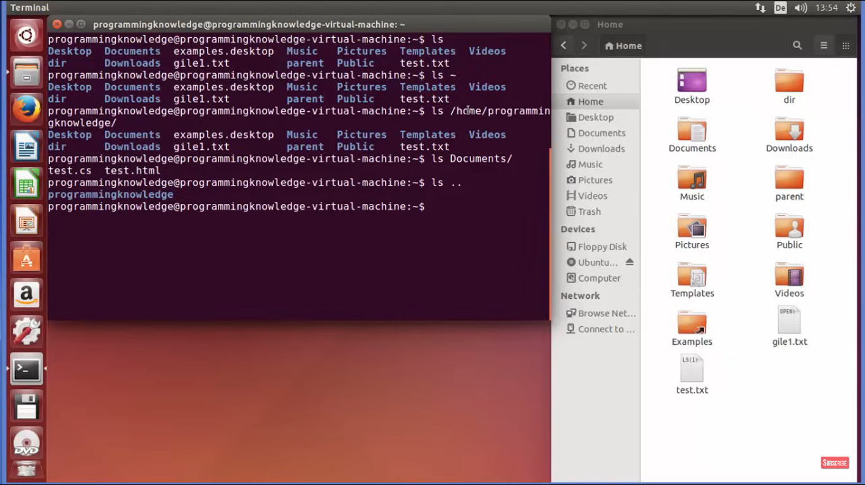

**>> ls.. /.. -> Two step back**

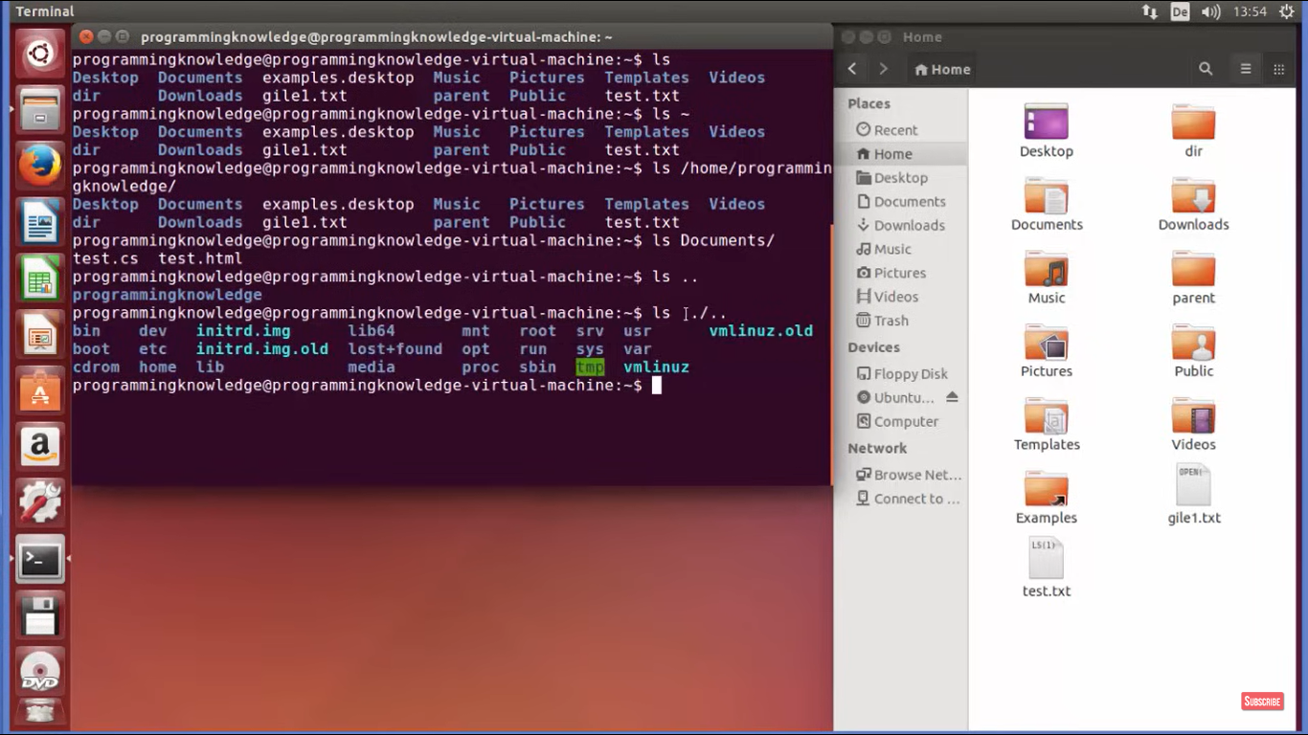

**>>ls –l -> It gives the content in long format -> It gives the detail who is user, size, permissions, Time**

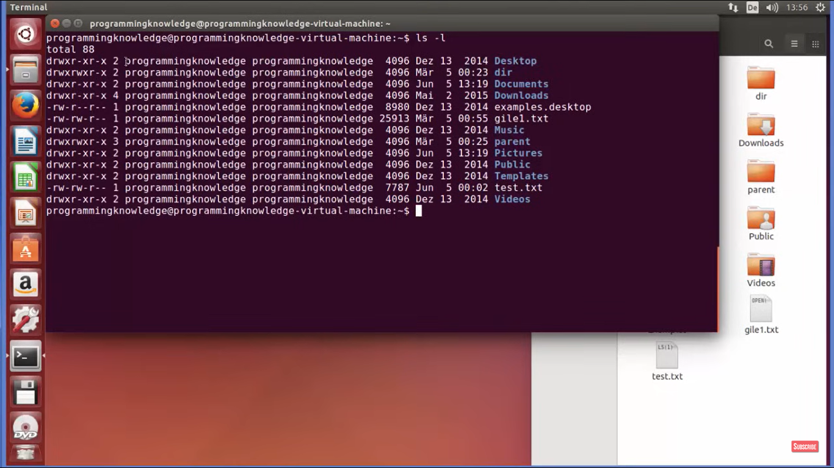

**>>ls –a 🡪 It gives all the hidden files**

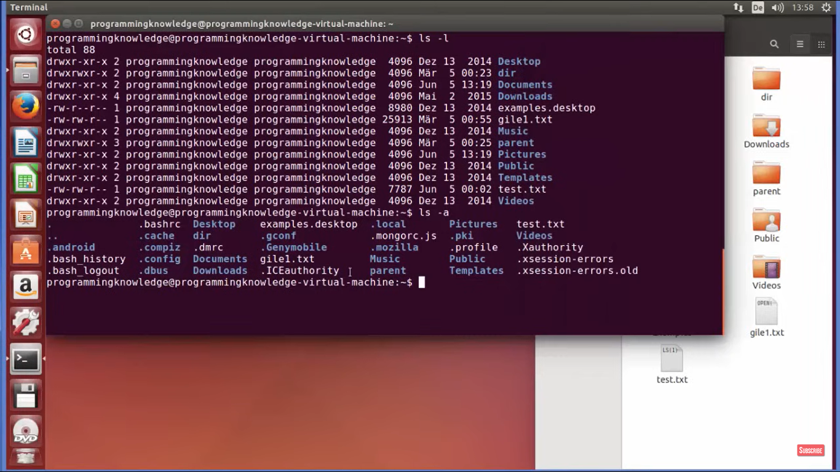

**In the above . represents the hidden file.**

**>>ls –al -> it gives the hidden file and long list**

